System Report
User Manual

This is the user manual for the central locking system designed by myself for the Electronics and interfacing coursework. It is designed to be run off of an Arduino.
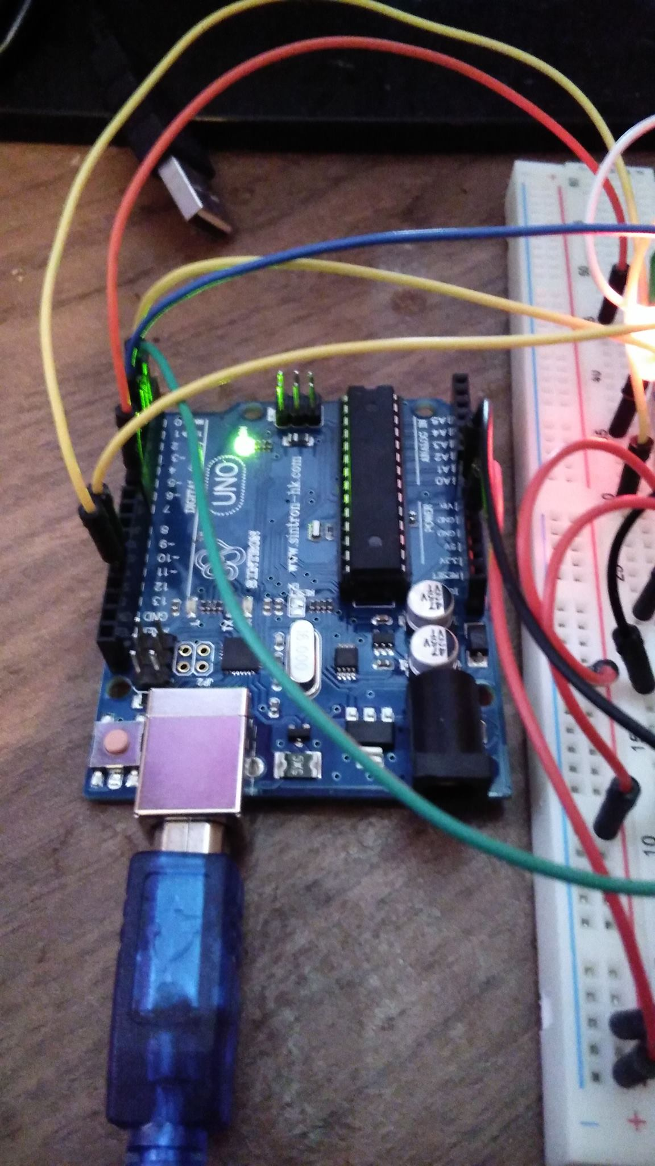Illustration I: This is and example of an Arduino that could be used to run the program for the alarm. The green LED at the top of the image indicates that the Arduino is powered on, the LED on the far right of the 3 LEDs just above the input port is the LED used to indicate when an input from the remote has been received.
This central locking system will lock one item with one system of detection, it will sound a pulsed alarm when triggered.
The alarm can be armed either via an infrared remote control or via a button located upon the device, when setting the alarm via the remote control the interact button must be pressed followed by the passcode in sequence. To disarm the alarm the interact button must be pressed on the remote followed by the passcode. When entering the passcode via the remote your inputs can be monitored both by a light which illuminates on the device after each input and by your input being output on the serial monitor.
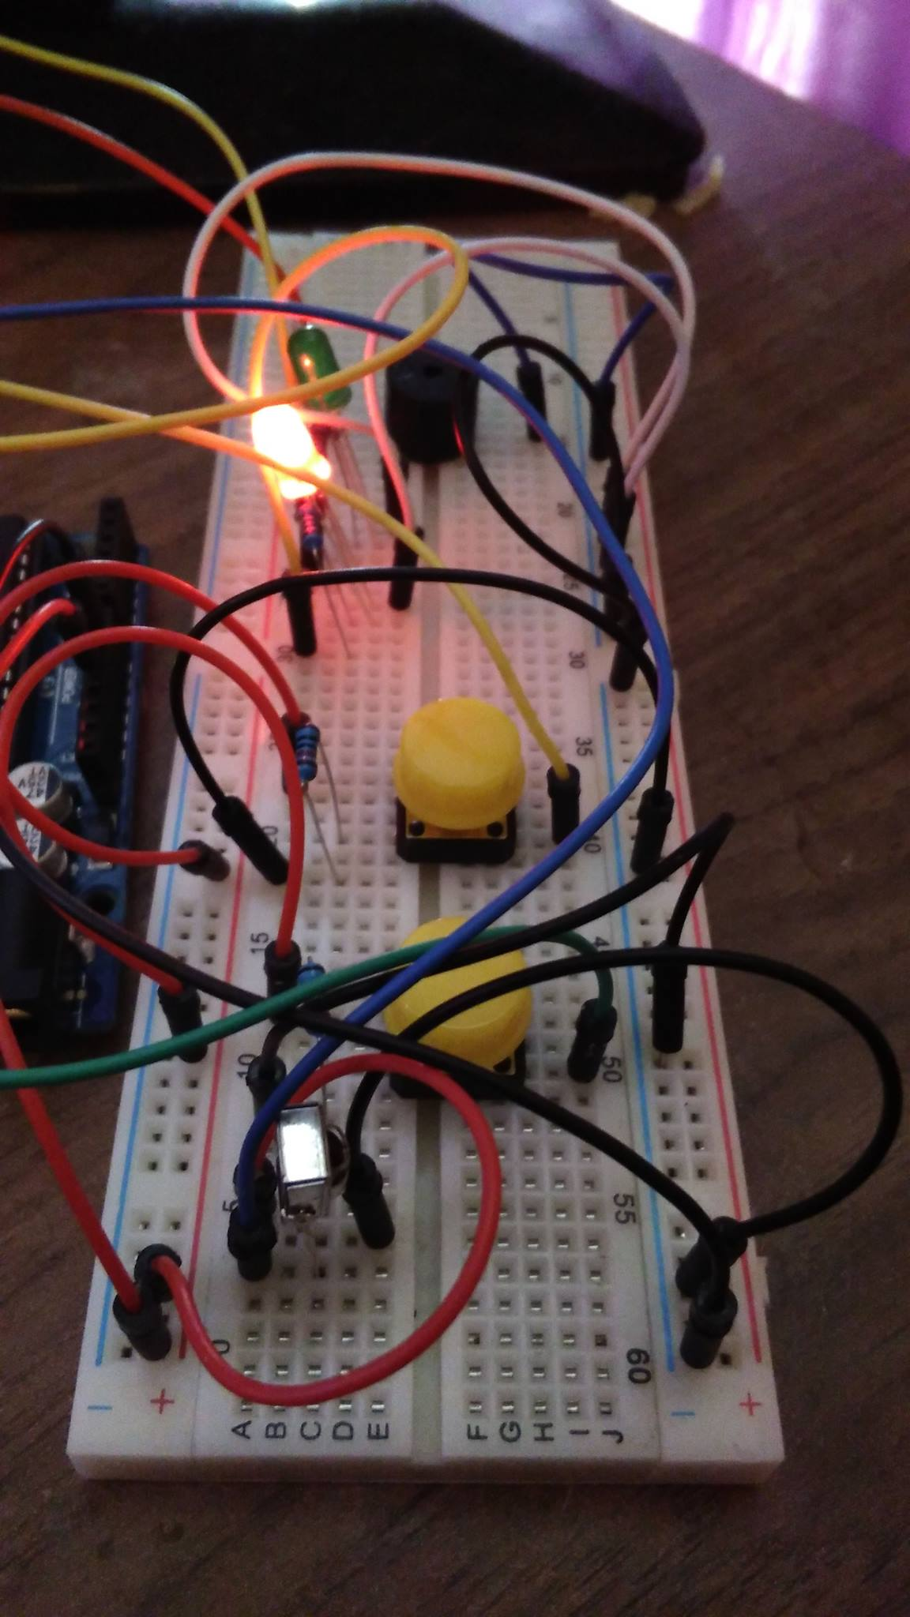Illustration II: This is a breadboard of the components for a prototype of the device. The black cylinder furthest from the camera is the buzzer which pulses if the alarm is alarmed. The two LEDs are the status indicator LEDs. The button furthest from the camera is the button to arm the alarm and the button closest to the camera is the button to trigger the alarm. The small silver cuboid closest to the camera is the infrared sensor which takes the input from the infrared remote.
After arming the alarm a 20 second exit delay will be initiated which is indicated by a pulsed alarm.
The passcode will be set when powering on the alarm, the passcode will be set via the serial monitor. The device can use up to 2 passcodes that will be stored even when the device is powered off. When powering on the device a prompt will appear asking if you would like to use the previously stored passcode you can respond with either 'Y' or 'N', entering 'Y' will use the previously stored passcode and entering 'N' will prompt you to enter a new passcode. To enter a new passcode you must type a 4 digit passcode and then press enter. After entering the first passcode a prompt will appear asking if you would like to use another passcode you can respond with either 'Y' or 'N', entering 'Y' will prompt the same sequence as above and entering 'N' will start the system running with only one passcode.
Illustration III: This is an example of an infrared remote. Here the power button is used as the interact button and the numerical keypad is used to enter the passcode
The status of the device can be determined by the two LEDs upon the device. Red means the alarm is not armed, green means the alarm is armed and both LEDs illuminated means the alarm is alarmed. The status of the device can also be determined by an output to the serial monitor.
If at any time an input is invalid the device will indicate so via the serial monitor and allow you to reattempt an input.

System Overview

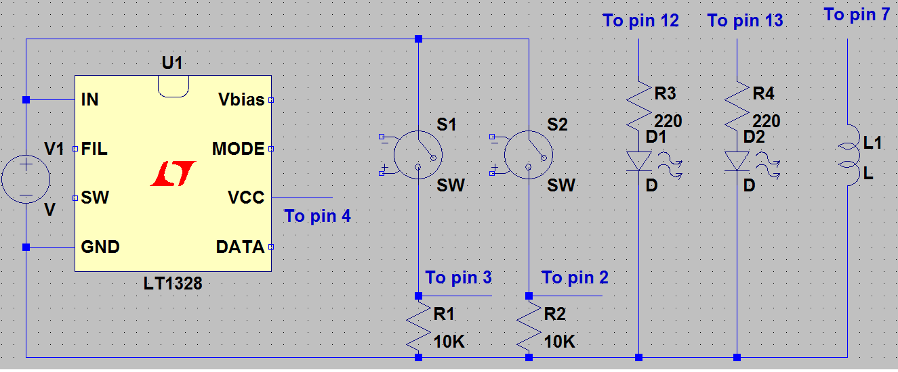Illustration IV: This is a circuit diagram of the breadboard used to prototype the alarm circuit. U1 is being used to represent the infrared sensor, it takes +5v from the power rail and returns to the ground power rail, pin 2 on U1 goes to pin 4 on the Arduino. The voltage controlled switches S1 and S2 are being used to represent the switches which control the state of the device, S1 is the trigger for the alarm and S2 is the arming button for the alarm, both switches take +5v from the power rail and return to ground power rail, S1 pulls to pin 3 on the Arduino and S2 to pin 2. D1 and D2 are being used to represent the state indicator LEDs both have a 220ohm resistor between it and its pin and are connected to the ground power rail, D1 goes to pin 12 on the Arduino and D2 to pin 13. The inductor L1 is being used to represent the siren that indicates both the exit delay and that the alarm has been triggered, it is connected to the ground power rail and pin 7 of the Arduino.
Inputs
Infrared remote control | The infrared remote control is used to both arm and disarm the alarm. It does this by first sending a signal to prime the device to receive a passcode and then sends a passcode at the discretion of the user.
Arm button | The arm button is used to arm the alarm directly in lieu of using the infrared remote control. No passcode is required if the arm button is used.
Alarm button | The alarm button is used to simulate a detection method for the alarm. When it is pressed the state of the alarm is changed to alarmed if the alarm is currently armed.
Serial monitor | The serial monitor is used to initialise the alarm. Both passcodes are entered via the serial monitor.

Outputs
Siren | The siren pulses to represent both the exit delay after the alarm is initially armed and to illustrate that the alarm has been triggered.
Red LED | The red LED is used to represent that the alarm is currently disarmed. The red LED also comes on in conjunction with the green LED to represent that the alarm has been triggered.
Green LED | The green LED is used to represent that the alarm is currently armed. The green LED also comes on in conjunction with the red LED to represent that the alarm has been triggered. Because of the pin used to interface with the green LED it will also flash to represent when information is being sent through the serial port to the Arduino.
Arduino LEDs | The LEDs on the Arduino show when the Arduino is receiving input.
Serial monitor | The serial monitor is not only used while setting up the alarm but will also output relevant messages during the usage of the alarm eg. It will show you infrared inputs that the Arduino is receiving and will also show the alarms current state.

Software Description

Setup
Setup initialises all of the variables that are to be used in the program including querying the user as to the number of passcodes they wish to use. Setup also calls the method to add these passcodes.

CodeSetup
Firstly this method checks to see if there is a passcode in EEPROM that can be read rather than creating a new one. If there is it gives the user the option of using this passcode. If the user chooses not to use this passcode or there is no passcode stored in EEPROM the method then asks the user to input a passcode digit by digit. If the passcode was not read from EEPROM the method then stores the new passcode in EEPROM.

ISR
This method is called by the clock every half a second. If the alarm has been triggered or the alarm is being set this sounds the siren. If the alarm is off it turns it on if it is on it turns it off. A count variable is used to ensure that if the alarm is being set it only sounds for 20 seconds. A toned boolean also ensures that the siren cannot be left stuck on.

Loop
This is the main method of the program. Initially it checks to see if the interact button on the remote has been pressed, if it has it then checks to see if it is a valid time to perform actions on the alarm. Then it checks to see if the alarm has been triggered or has been armed, if not it checks the code entered if it is incorrect it informs the user if not it either arms or disarms the alarm.

ArmKeyEvent
This is the interrupt method for the arm button. This simply calls the arm method.

InitialiseArm
This method causes the exit delay to occur in the ISR method which will then in turn call the Arm method

Arm
The Arm method calls the lock method and then changes the state of the device to armed and switched the LEDs from red on to green on.

Lock
If the device is not locked changes a Boolean to represent something being locked.

Disarm
Exactly the same as Arm but in reverse.

Unlock
Exactly the same as Lock but in reverse.

AlarmKeyEvent
This is the interrupt method for the alarm button. This simply calls the alarm method.

Alarmed
If the alarm is armed this indicated that the alarm should be sounded and turns both LEDs on.

CheckCode
This method initialises two temporary variables one that will contain the temporary code and one that is an array of booleans equal to the number of codes. It then takes an input from the remote digit by digit and checks this digit against all of the codes if the number in the temporary code does not match the number in the passcode it makes its boolean false. If any of the booleans are still true after checking all places in the code then the temporary code and passcode are the same.

RemoteInput
This method initially takes the input from the remote and then checks it against the universal preamble for the remote if this is correct it checks all of the known pulses and returns the number sent by the remote.

ListenForIR
This method increments two variables by one for each time that the input from the infrared sensor is high or low and then adds this number to an array.

PreambleCheck
This reads the preamble from progmem into a temporary buffer and then checks the input against it.

ButtonCheck
This does the same as PreambleCheck but checks each known button in turn returning the output when it is know.

IRComparePreamble
This checks all the high and the low pulses for the first 18 pulses in turn against a known number with a margine for error of about 20%. If any of the checks fails this returns false.

IRCompare
This does exactly the same as IRCompare but for the pulses after 18.

Finite State Machine
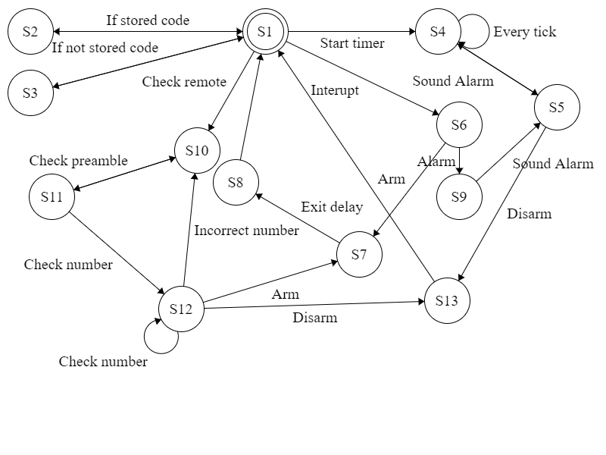
Testing
Entered y as input | Passed
Entered Y as input | Passed
Entered N as input | Passed
Entered w as input | Invalid input
Entered 1234 as code | 1234 code
Entered 12345 as code | 1234 code
Entered 123 as code | Code rejected
Used stored code | Stored code 1234
Entered 9876 as second code | 9876 second code
Used stored second code | 9876 second code
Pressed arm button | Armed and exit delay
Pressed arm button | Already armed
Pressed alarm button | Pulsed siren
Pressed alarm button | No effect
Pressed arm button | No effect
Entered 1234 via remote | Disarmed and siren ceased
Entered 1836 via remote | Code rejected
Entered 10 via remote | Code rejected
Pressed arm button then Entered code | Armed and exit delay
Entered mute button | Code rejected
Entered 1 and 2 simultaneously | Code rejected
Pressed alarm button | Alarm not armed

Conclusion
In conclusion, it was quite different programming for an Arduino rather than a normal computer because of its limited memory and lack of multi-threading. To conserve memory I ended up putting my arrays from my header file into program memory which is something I haven't had to do before, it was interesting to learn about how this worked especially how to read things back from program memory using a buffer, also because of low memory I learnt about putting strings into program memory too using the F() command. Because of the lack of multi-threading I ended up using a lot of interrupts which some could argue is a bad thing. I read a lot about how the clock in the Arduino works and how to use this to schedule tasks, through this reading I also discovered that there are in fact 3 clocks that the Arduino uses. I would say that the faux multi-threading I implemented was effective at getting the job done, it did allow multiple processes to be run simultaneously. However, something I would do differently if I was to do it again would be to remove as many of the interrupts as I could because it is impossible to know what code the interrupts are interrupting and because of the way the infrared is read the interrupts could cause the wrong digits to be returned. This could cause a lot of issues if the program was built upon by someone else who didn't understand it as well as I did. Thus a better method would be to set flags with the interrupts that the main loop of the program would then check and act upon, therefore I would always know what code was doing what when.

